Landowners Guide to Tree Planting
Site Preparation
Proper site preparation is key to planting success. Lack of site preparation is a leading cause of seedling mortality. Eliminating cool season grass, will reduce the amount of competition for water, sunlight, and nutrients, giving your trees the best chance at becoming established. For old pasture sites, combining mowing and herbicide, tilling and herbicide are most effective. Herbicide treatments can include broadcast, spot or row applications. This is usually done in the fall while vegetation is still green prior to the following spring planting. Ask Lower Thames staff for advice on preparing your site!

Transportation and Storage
When transporting, take care to protect seedlings from exposure to direct sunlight. If transporting in a truck bed, cover with a tarp! Handle the trees carefully, careful not to damage stems and buds. Buds are the source of new growth, which the tree will need to get established!
- Plant seedlings soon after they arrive, preferably within 24 hours and no longer than one week.
- Store seedlings in a cool, damp environment in original packaging.
- Keep roots moist (do not soak) mist or lightly spray water onto the seedlings, and do not handle seedlings until you are ready to plant.
Planting
At the planting site, keep extra seedlings wrapped tightly in their original packaging, covered with a reflective tarp, and stored in the shade. The tree hole must be deep and wide enough to accommodate the entire root system. If roots are drying out, dip in water but do not leave submerged.
- Allow roots to hang naturally, don’t bunch, wrap or bend the roots.
- Make sure seedling is straight and that roots are covered by soil.
- Soil should be level or slightly higher than the root collar (where stem turns to roots).
- Pack soil firmly around the tree, being careful not to bury any branches.
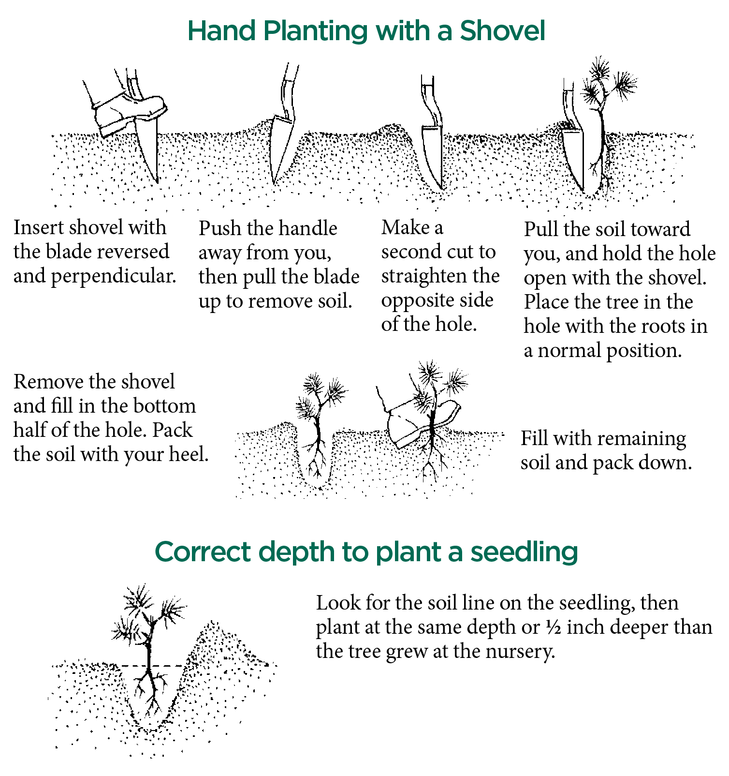
Figure 1: Proper Hand Planting Technique
Shovel Hand Planting
Correct Planting Depth

Maintenance and Weed Control
Hold on, you aren’t done yet! Post planting maintenance is a very important step. Lack of weed control is the primary reason for planting failure. Effective weed control enhances tree survival and growth, and results in faster establishment.
- Site maintenance is the landowner’s responsibility, with the first three years after planting being the most important to achieve optimal survival, growth rate, and establishment.
- Maintenance includes: Mowing and maintaining a grass free zone around the stem (approximately 1’ or 30cm diameter) using herbicide or mulch. Always make sure to have proper training and safety equipment before using chemical treatment.
Mulching can be an excellent method of weed and vegetation control around trees, although it can be very labour intensive. A four to six inch layer of mulch material (wood chips, sawdust, straw, newspaper, etc.) can provide weed control and conserves moisture around the plant, reduces temperature extremes, and provides nutrients as it decays. Be careful to pull mulch away from the stem and bank high on the outside to avoid stem rot.

